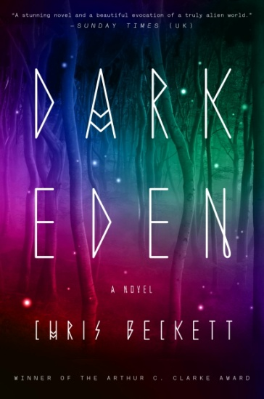
Reading Group Guide
DARK EDEN
Chris Beckett

Eden is a planet outside of the galaxy that has no sun of its own, but has evolved its own form of life that uses heat from the planet’s core, and produces luminescence like deep sea creatures on Earth. Generations before the beginning of the book, a group of astronauts found themselves stranded there with a damaged spacecraft. Three of the astronauts elected to try and return to Earth. Two, a man and a woman, decide to remain and wait.
DARK EDEN by Chris Beckett
On-sale: April 1, 2014 - 464 pp.
TRADE PAPERBACK: 9780804138680
EBOOK: 9780804138697

At the time the book is set, their five-hundred-odd descendants are still waiting at the spot where the original landing vehicle touched down, hoping for rescue from Earth. Having begun as a family, they still just call themselves Family. They are in a small valley, surrounded by mountains that are not only cold but completely dark, and it is very slowly becoming apparent that food resources will eventually be insufficient to feed their growing population.
A young man, John Redlantern, proposes that Family attempt to cross the mountains and find new land. This is opposed by the older generation, not only because of the danger, but also because of fears of breaking up Family, and of not being in the right place if rescuers should ever come from Earth. John reacts by destroying the circle of stones that marks the place where the astronauts first landed, and he is expelled from Family.
He gathers a small group of young people around him, including his girlfriend, Tina, and his cousins, Gerry and Jeff, intending eventually to attempt the crossing himself. Tensions with the rest of Family escalate to a point where John and two of his companions react to an attack by killing three Family members, the first time in Eden that a human being has ever killed another. After this, John’s group has no choice but to leave the valley straightaway via the mountains.
CHRIS BECKETT is a university lecturer living in Cambridge. His short stories have appeared in such publications as Interzone and Asimov’s and in numerous “year’s best” anthologies. To connect with Chris, visit his blog at http://www.chris-beckett.com/blog/.

Please note: In order to provide reading groups with the most informed and thought-provoking questions possible, it is necessary to reveal important aspects of the plot of this novel—as well as the ending. If you have not finished reading DARK EDEN, we respectfully suggest that you may want to wait before reviewing this guide.

Discussion Questions:
- How have the origins of Eden shaped the society it has become?
- Why has it been mainly women who have run things in Eden up to the time of the story and why are men taking over in the world of Dark Eden? Is this what happened in the history of Earth?
- The first woman on Eden was faced with the choice of (a) attempting a return to Earth that would almost certainly end in death or (b) remaining on Eden with a man she didn’t know well and was not sure that she liked. What would you have done, faced with this choice?
- Why did Angela pass on the Secret Story to her daughters? Why not also to her son?
- What is your sense of the relationship between the original couple on Eden? How is it remembered by the people of Eden? How has it affected the development of Family generations on?
- The third generation on Eden could only exist if the second generation committed incest: what kind of consequences did this have, genetic and social?
- How do you think language would develop in a society that began as this one did?
- How would time be experienced in a world with no day and no night, no year and no seasons?
- Did John Redlantern do the right thing? If not, who had the better idea?
- John is a leader, as is David, but so are Caroline Brooklyn (the Family Head), David, Mehmet, Bella, and, in a way, Tina and Jeff as well. Who would be their counterparts in the contemporary world?
- Do you have to be an egotist to be a leader? What is John’s motivation for wanting to break away from Family?
- Is John Redlantern a hero or a menace? Is he a Moses or a Cain?
- How might the belief system of Eden evolve in future generations? What is the book’s view of the way that belief systems evolve over generations, and do you agree with it?
- What does the future hold for Eden at the end of the book? Has progress been made? Could things have taken a different or better course?
- What are the parallels and differences between this Eden story and the original biblical one?
- The story is told primarily by John and Tina, but also by several other narrators. What are the advantages and disadvantages of telling a story in this way?
- Could life really evolve on a planet without a sun?
- The relationship between the present, the past, and the future is important in this book. What does it say about how we deal with the past?
- The author of this book is a professional social worker. Do you see any reflection of that background in the way the book is written?
- As in Tolkein’s famous trilogy, a ring is very powerful in this story. What are the similarities and differences between the roles of the two rings?
- The author has identified William Golding’s Lord of the Flies as an influence on this book, as well as Russell Hoban’s Riddley Walker. What are the similarities and differences?
Want to hear about more great book club picks?
Visit www.ReadItForward.com and sign up for our enewsletter!

